# Setting up IAM Permissions for AWS Glue

A. Create an IAM policy for the AWS Glueservice

* Open the IAM console and select create policy

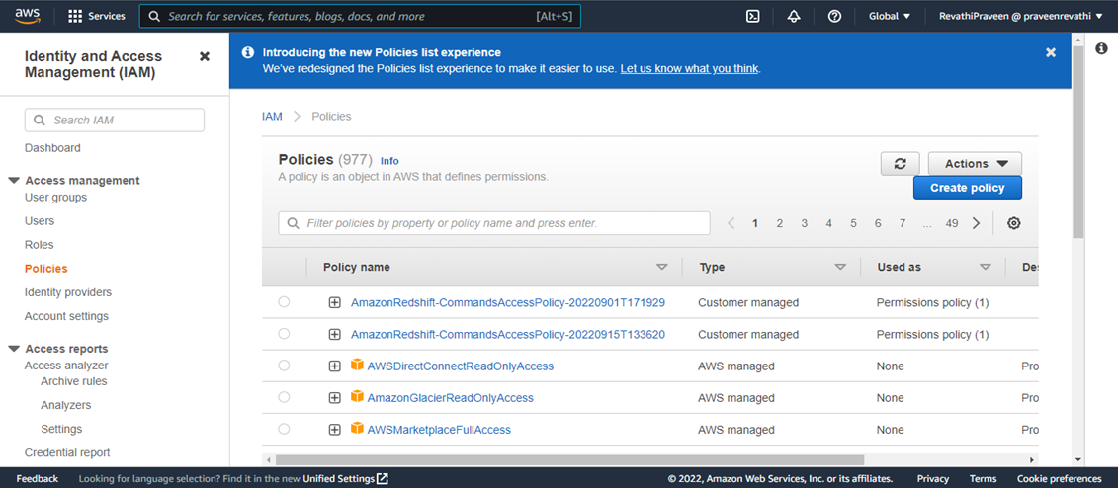

* Paste the Json file that contains the accesses required for the policy that is about to be created

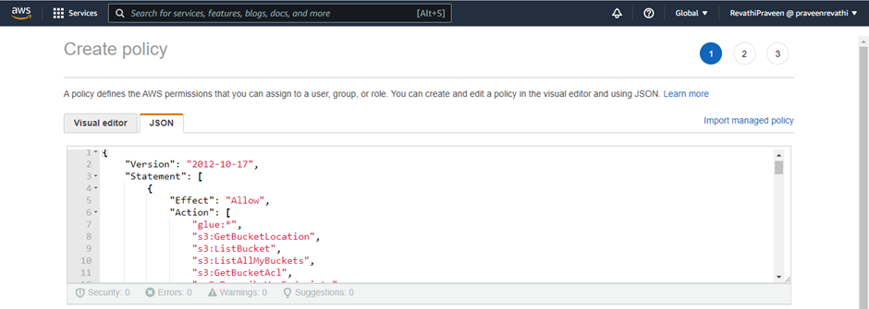

* Click on ‘Create policy’

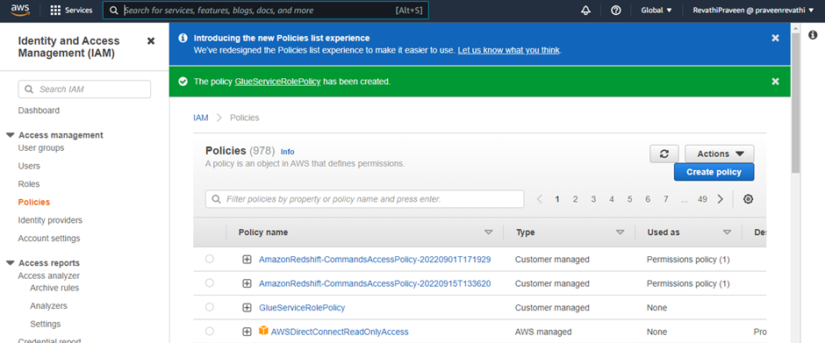

B. Create an IAM role for AWS Glue

* Click on ‘Create role’

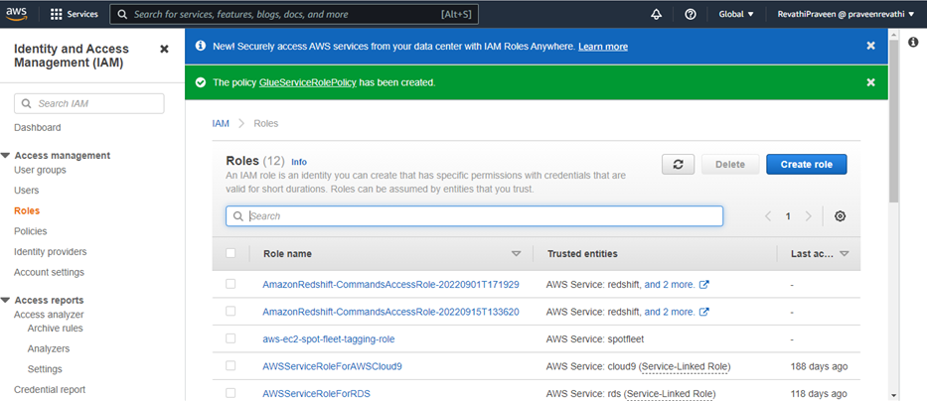

* Select the Glue service and then create role

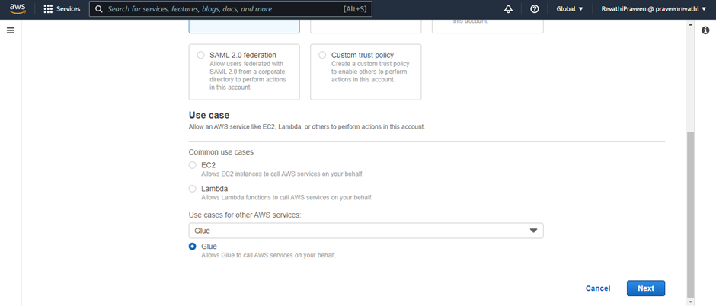

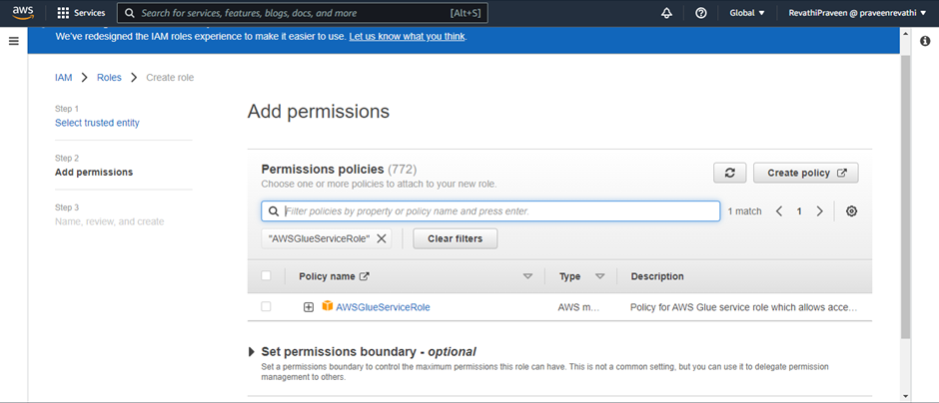

* Validate if the services ‘AmazonS3FullAccess’ and ‘AWSGlueService’ have been included in the role, then create the role

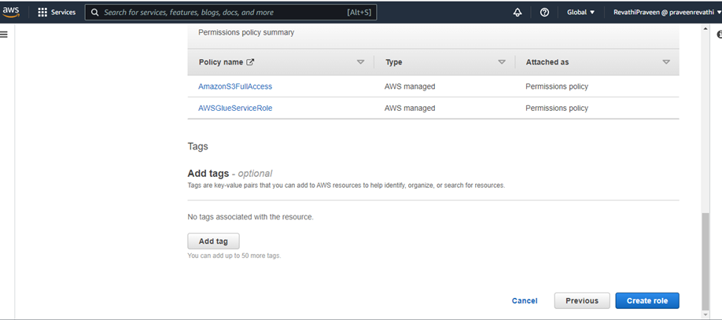

C. Attach a policy to IAM users that access AWS Glue

* Click on ‘users’ in the IAM console
* Choose the user for which the IAM policy is to be attached

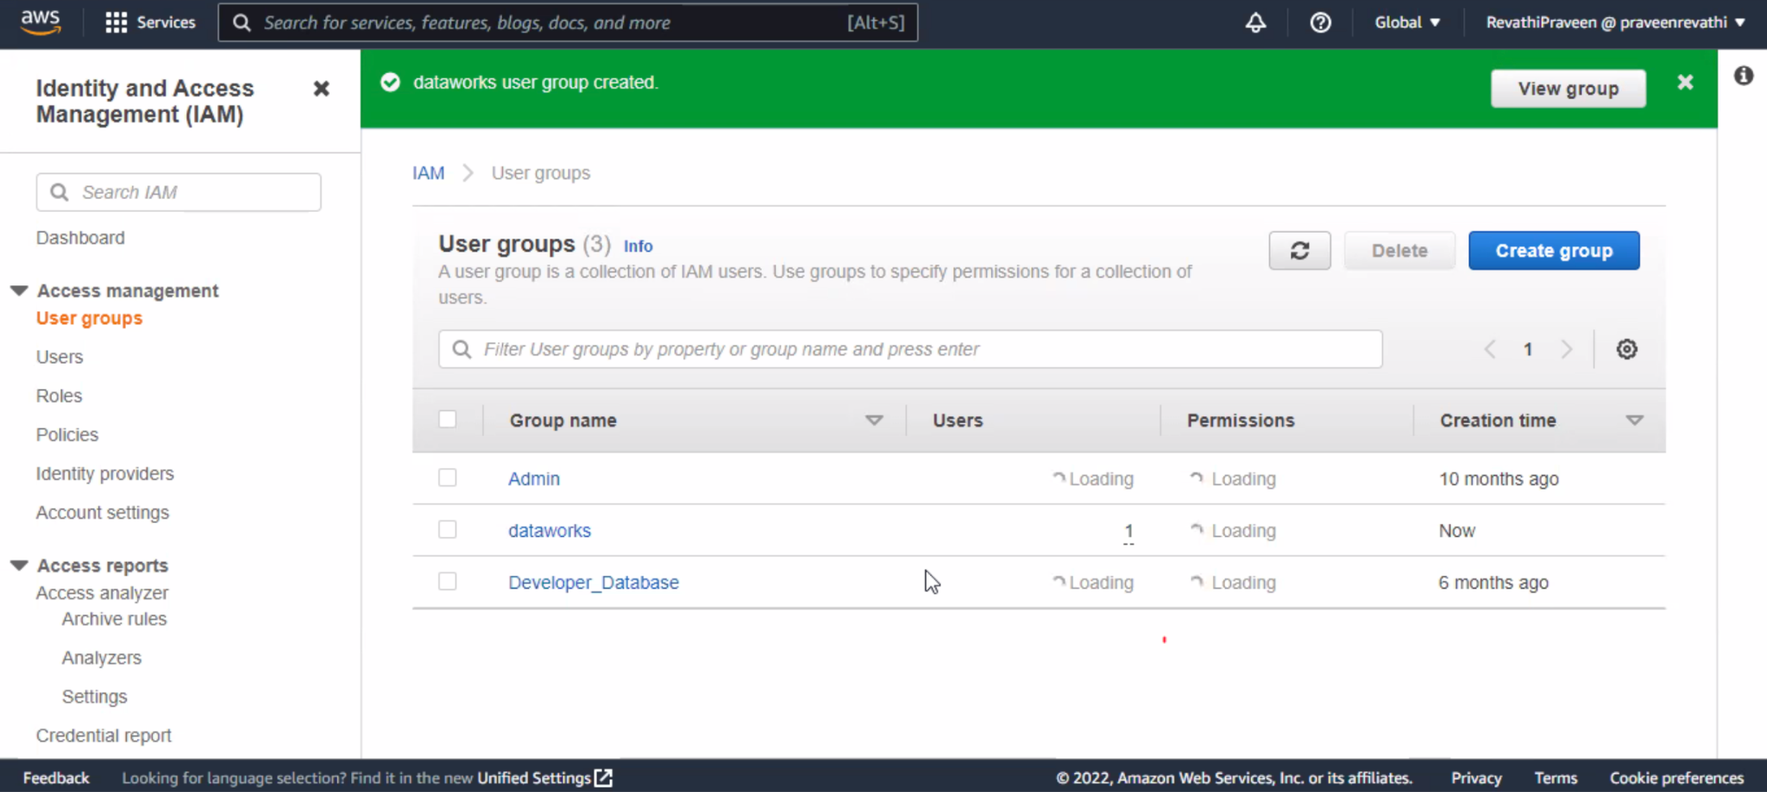

* Paste the JSON code that contains the necessary permissions, if the usage space is limited, then create user groups and then add an inline policy with the JSON code

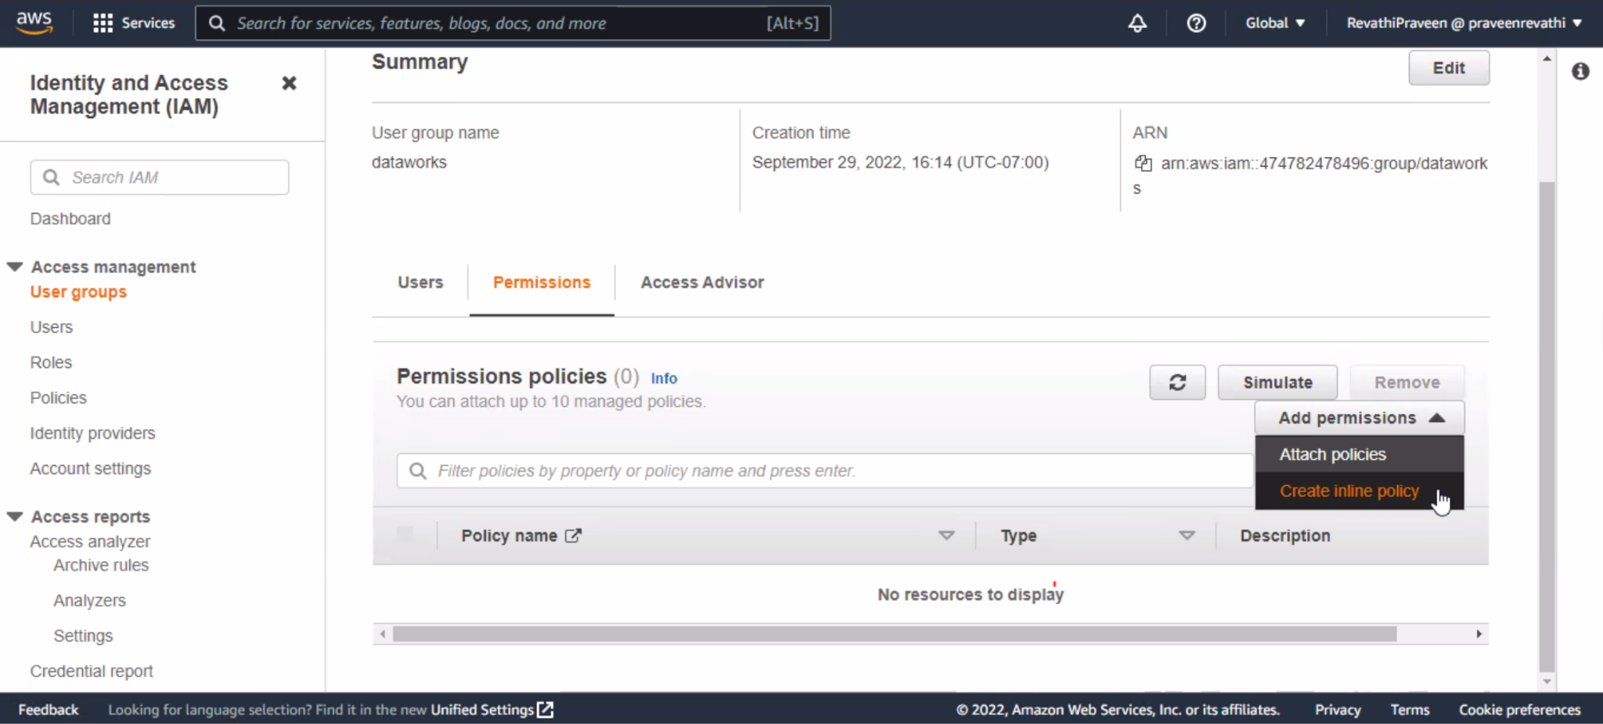

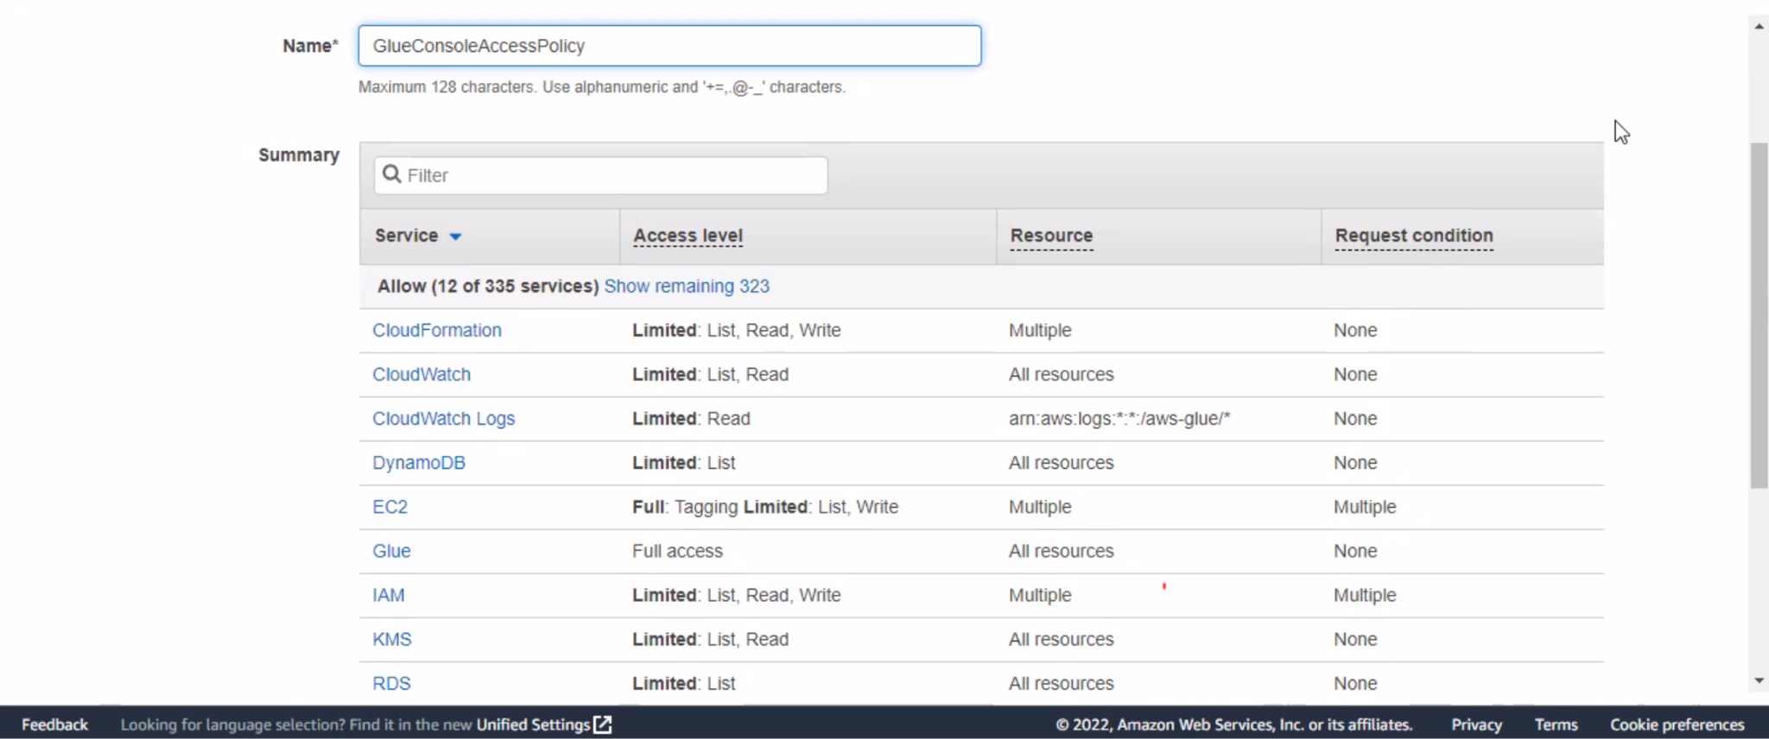

D.Create an IAM policy for notebook servers & Sagemaker notebook

* This step is a repetition of step A of policy creation
* Use the code for notebook creation in this case

E.Create an IAM role for notebook servers & SageMaker notebooks

* Similar to Step B in role creation, create a role for notebook servers & SageMaker notebooks as well by applying the corresponding permissions through JSON codes

# Setting Up DNS in Your VPC

* Ensure if DNS hostname and DNS resolution is enabled

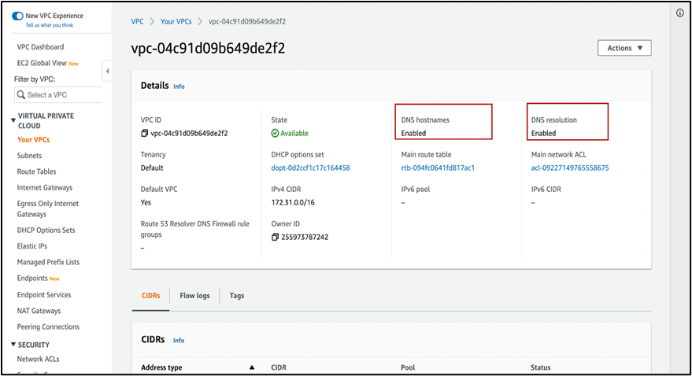

# Setting Up Your Environment to Access Data Stores

1. Amazon VPC endpoints for Amazon S3
2. In Amazon VPC console, Create Endpoint and follow the steps to create an Amazon S3 VPC endpoint of type Gateway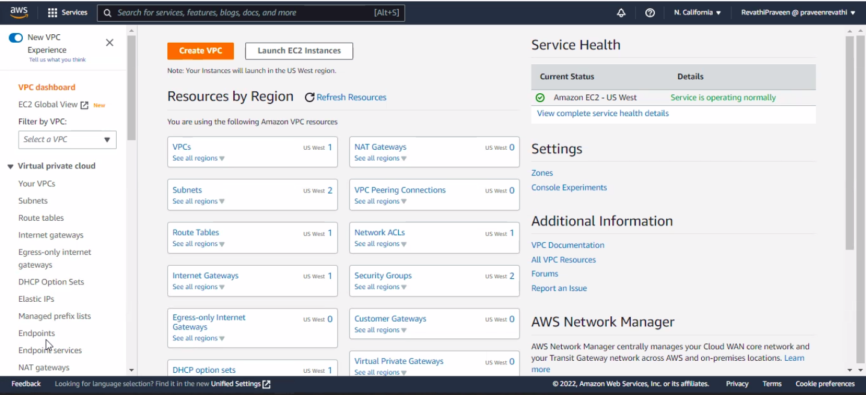

* Creating an Endpoint ensures that the Glue can access data from AWS S3 Bucket

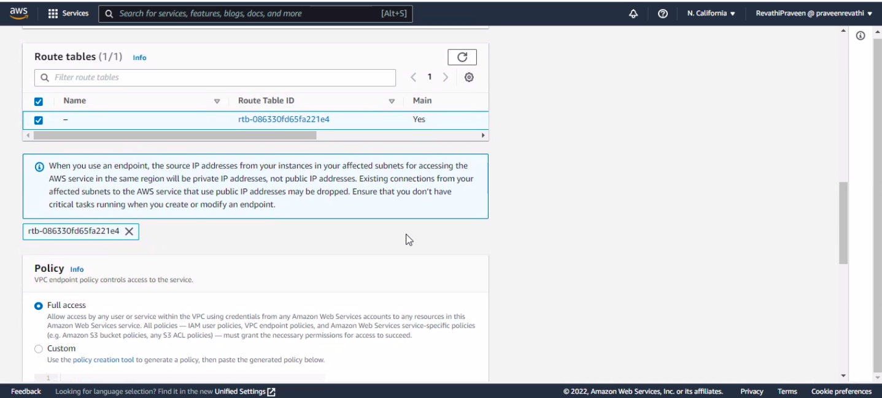

* The VPC Endpoint seems to be successfully created

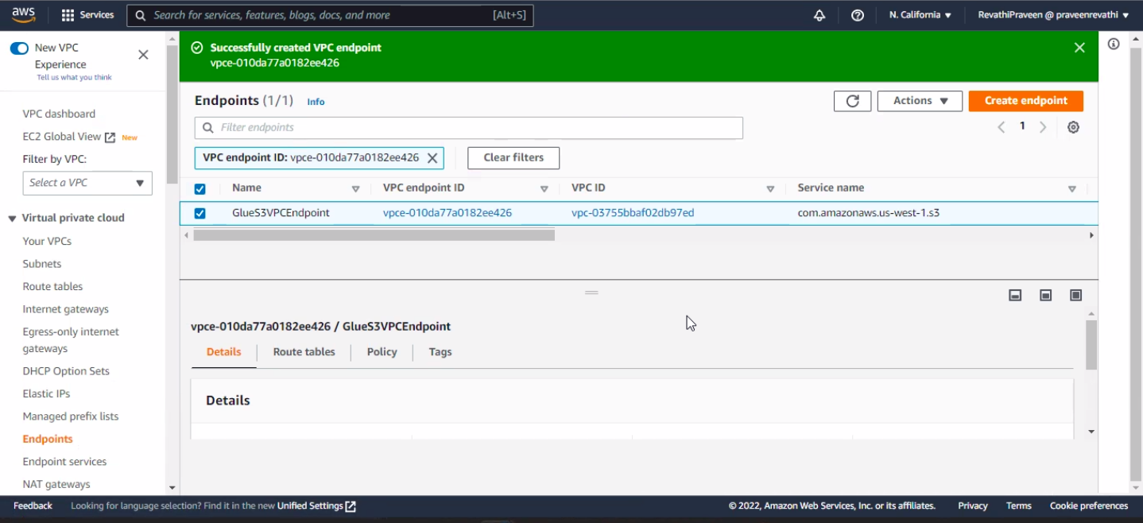

1. Setting up a VPC to connect to JDBC data stores for AWS Glue
2. In the Amazon Redshift console, Create Cluster and then set up security policy for the created cluster by clicking edit network and security

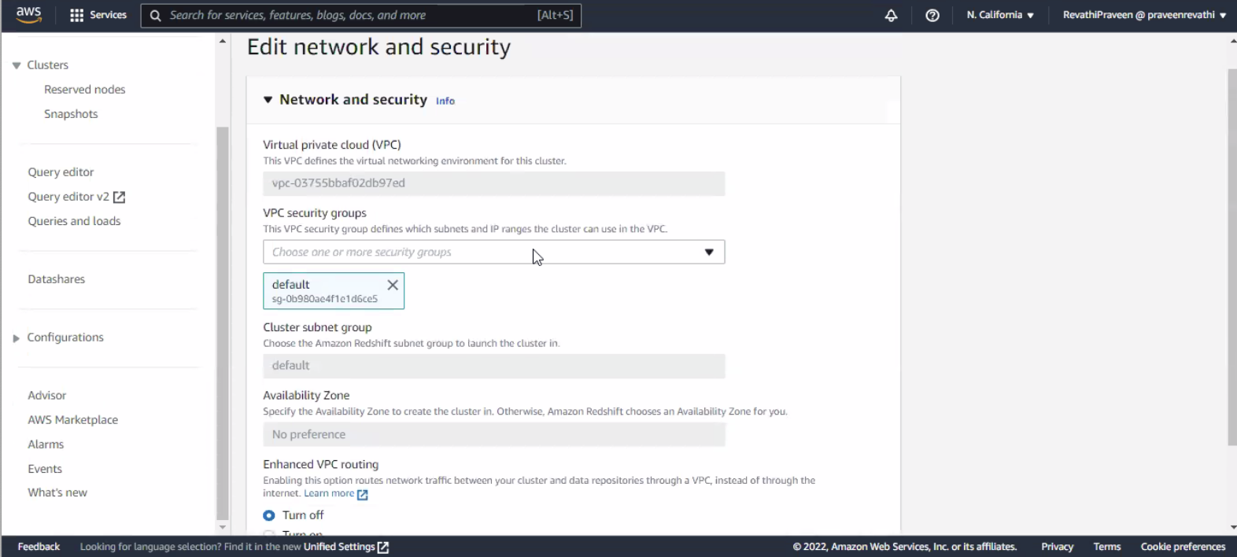

1. Adding Inbound rule

* Ensure ‘All TCP’ and ‘All Traffic’ type of Inbound rule has been set up and then save rules

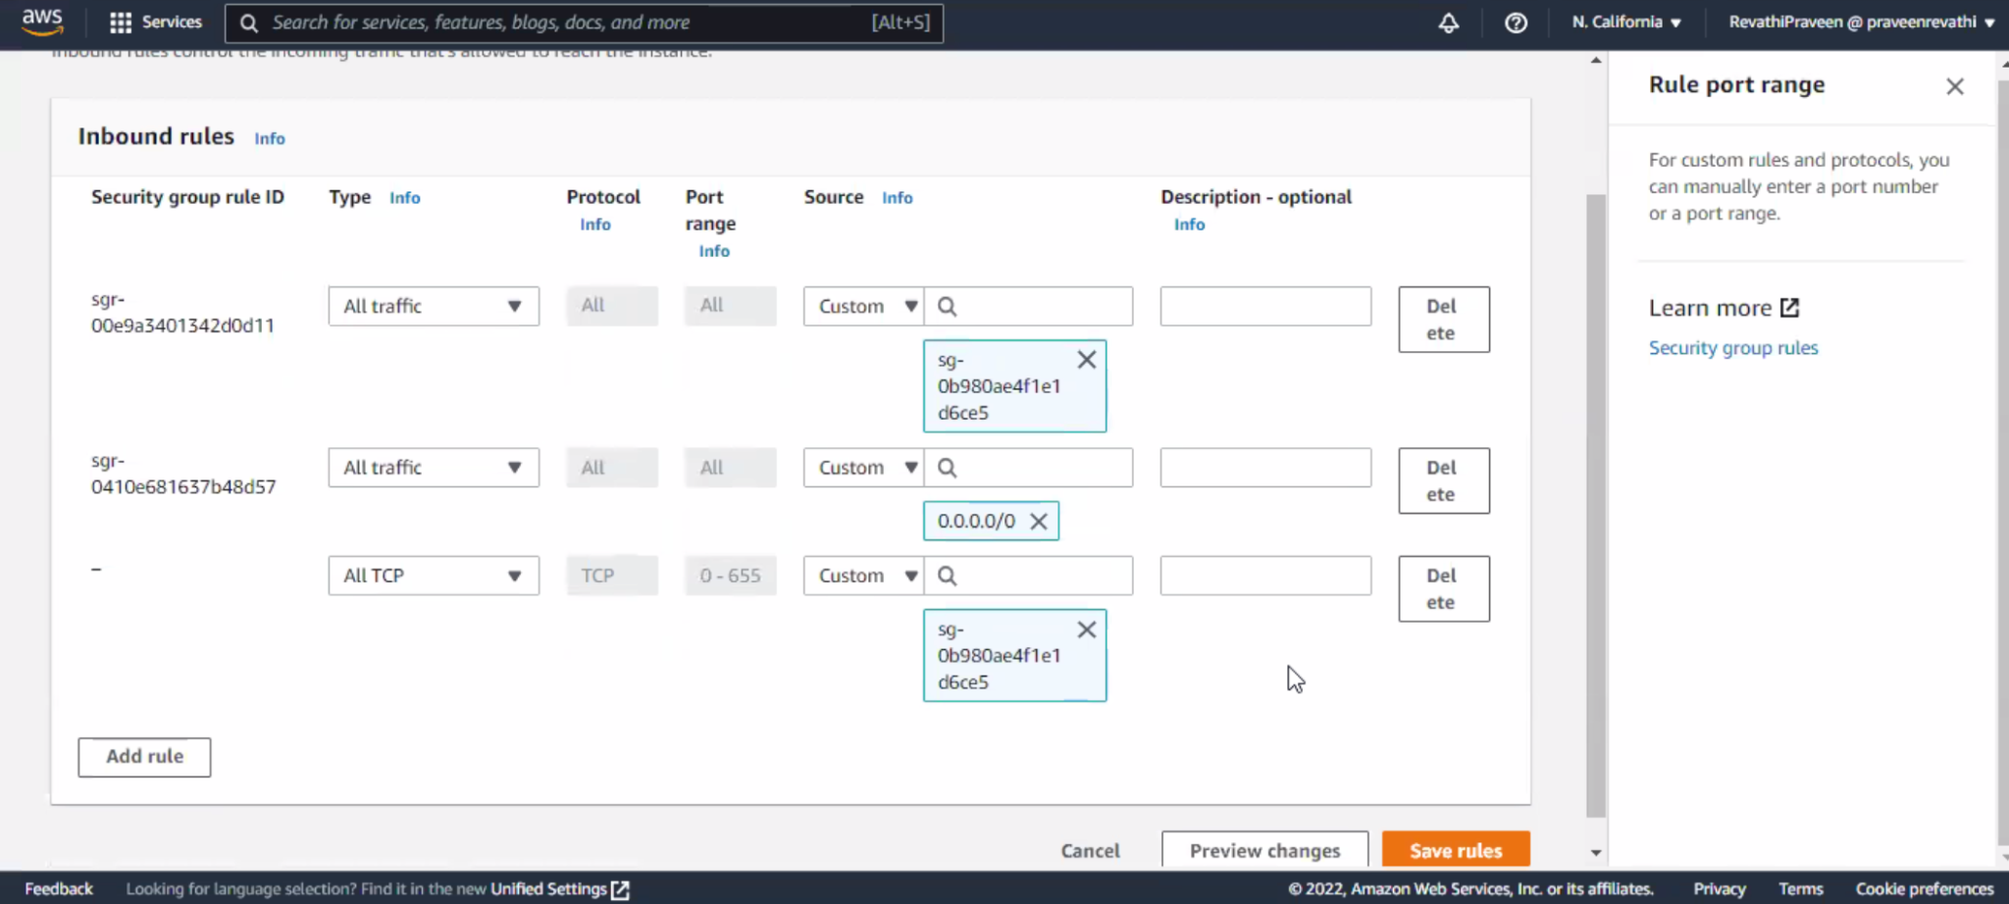

1. Adding outbound rule

* Similarly set up outbound rules as well by selecting the below criteria

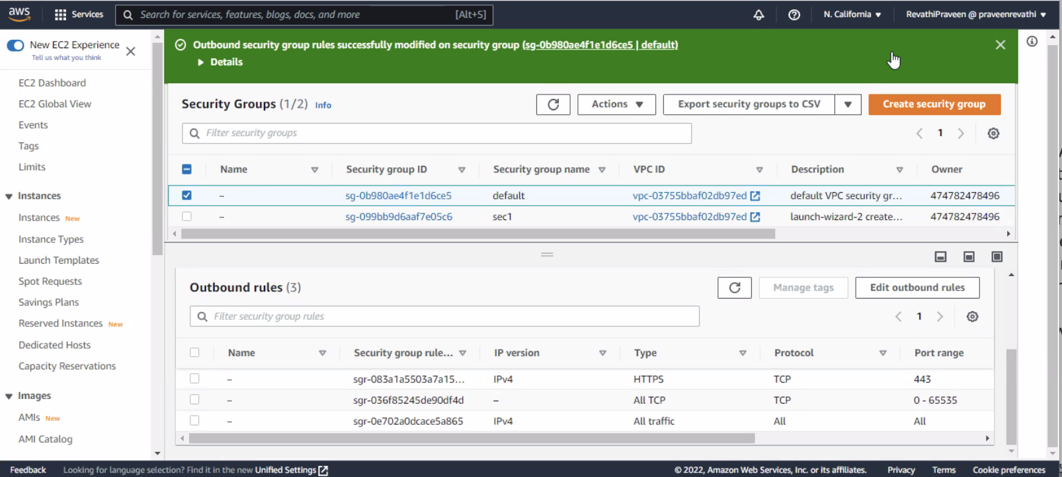

1. Setting up DNS in your VPC

The VPC network attributes enableDnsHostnames and enableDnsSupport must be set to true is validated again

# Setting Up Your Environment for Development Endpoints

A. Setting up networking for development for AWS Glue

1. In the left navigation pane, choose Security Groups.

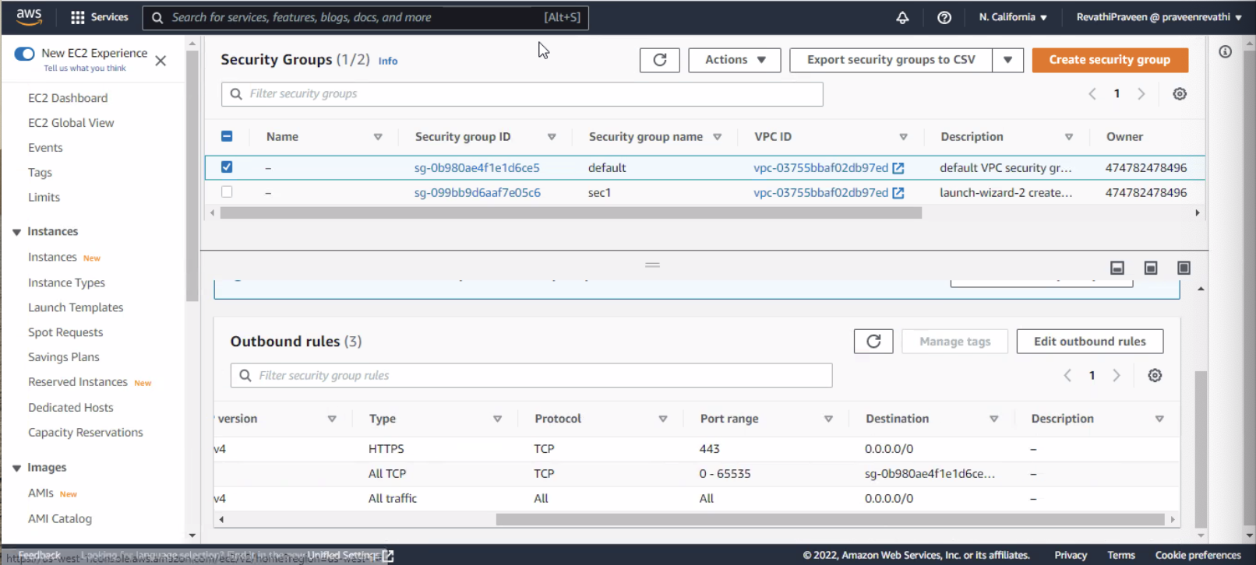

1. Create inbound rule



1. Create outbound rule



B. Setting up Amazon EC2 for a notebook server

1. In the left navigation pane, choose Security Groups.



1. Adding inbound rule

* This role enables incoming service availability based on specified criteria, this is similar to the inbung rules created for the clusters



1. Adding outbound rule



# Setting Up Encryption in AWS Glue

1. In the AWS Glue console, choose Settings in the navigation pane.

I. Encrypt the Data Catalog by selecting Metadata encryption.

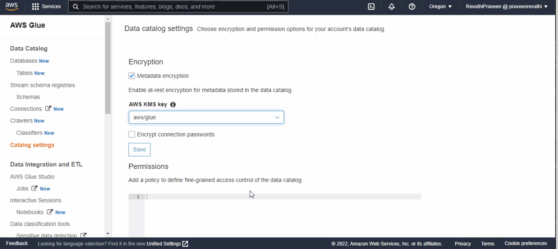

1. Set up the Security configurations

i. Select S3 encryption. For Encryption mode, choose SSE-KMS. For the AWS KMS key, choose aws/s3

ii. Select CloudWatch logs encryption, and choose a CMK.

Iii. Choose Advanced properties, and select Job bookmark encryption. For the AWS KMS key, choose aws/glue

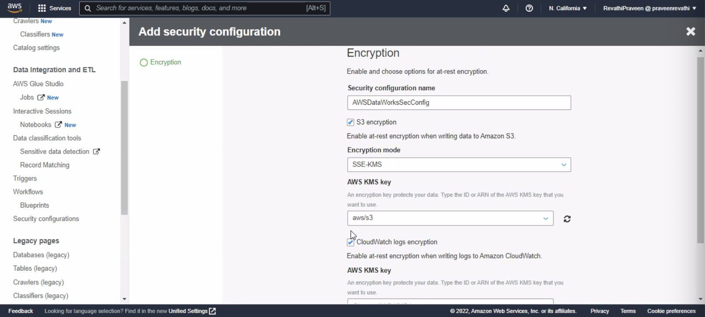

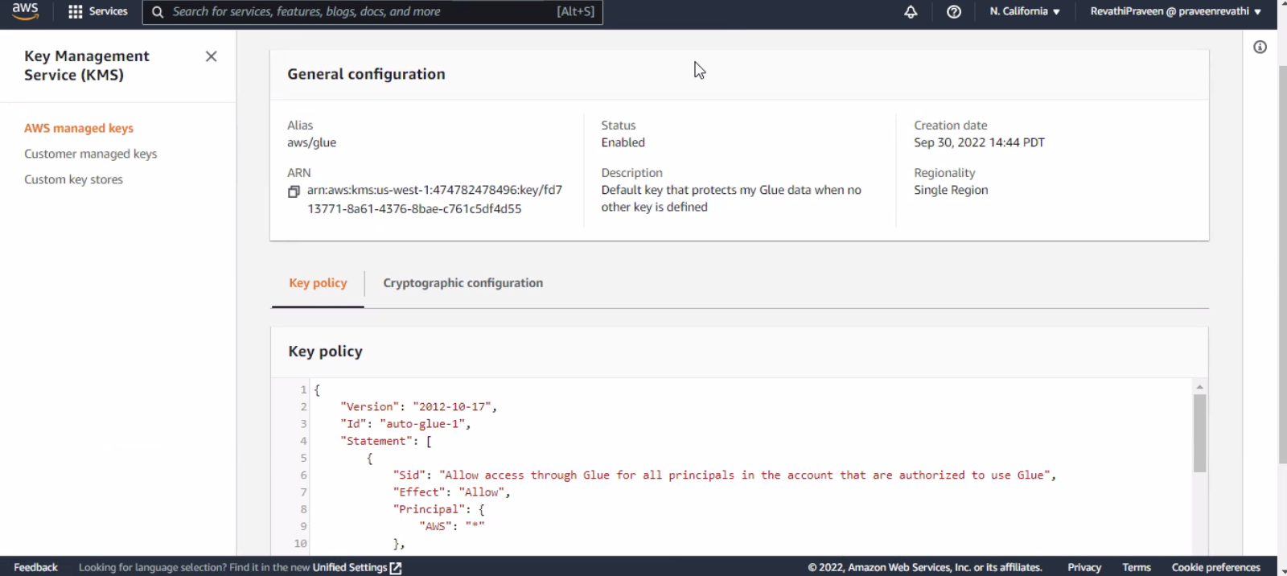  
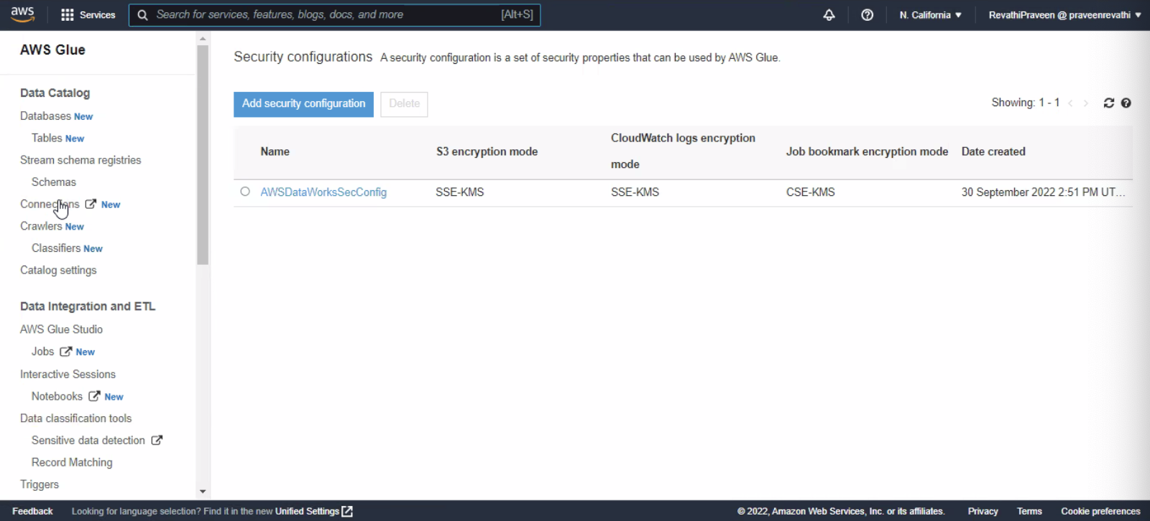

1. In the navigation pane, choose Connections.

i. Add connection

ii. select Require SSL connection to enforce that Secure Sockets Layer (SSL) encryption is used and test the connection

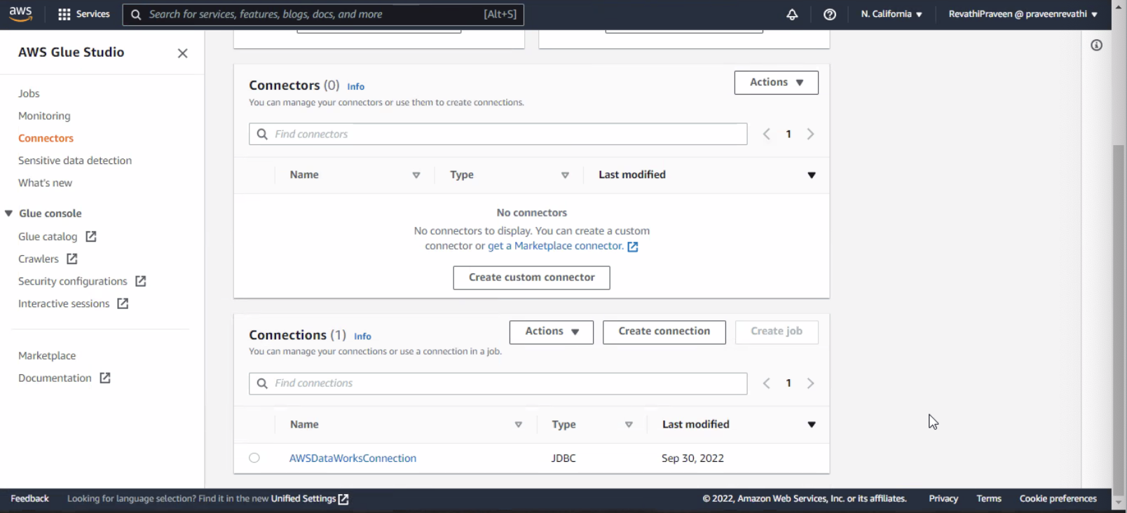

D. In the navigation pane, choose Jobs.

i. Choose Add job to create a job that transforms data.

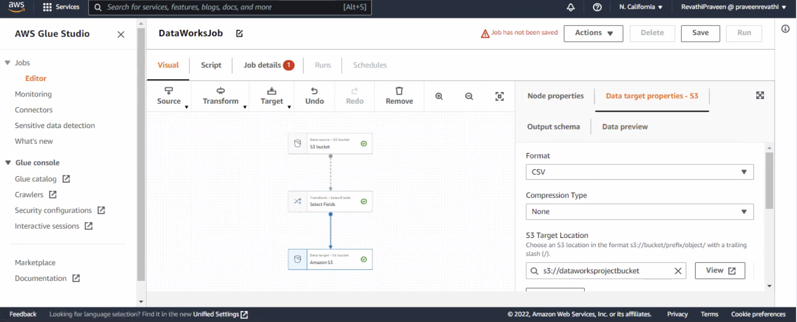

# AWS Glue Console Workflow Overview

1. Create crawler “DataWorksCrawler” and run the crawler to load the data from the S3 bucket to glue

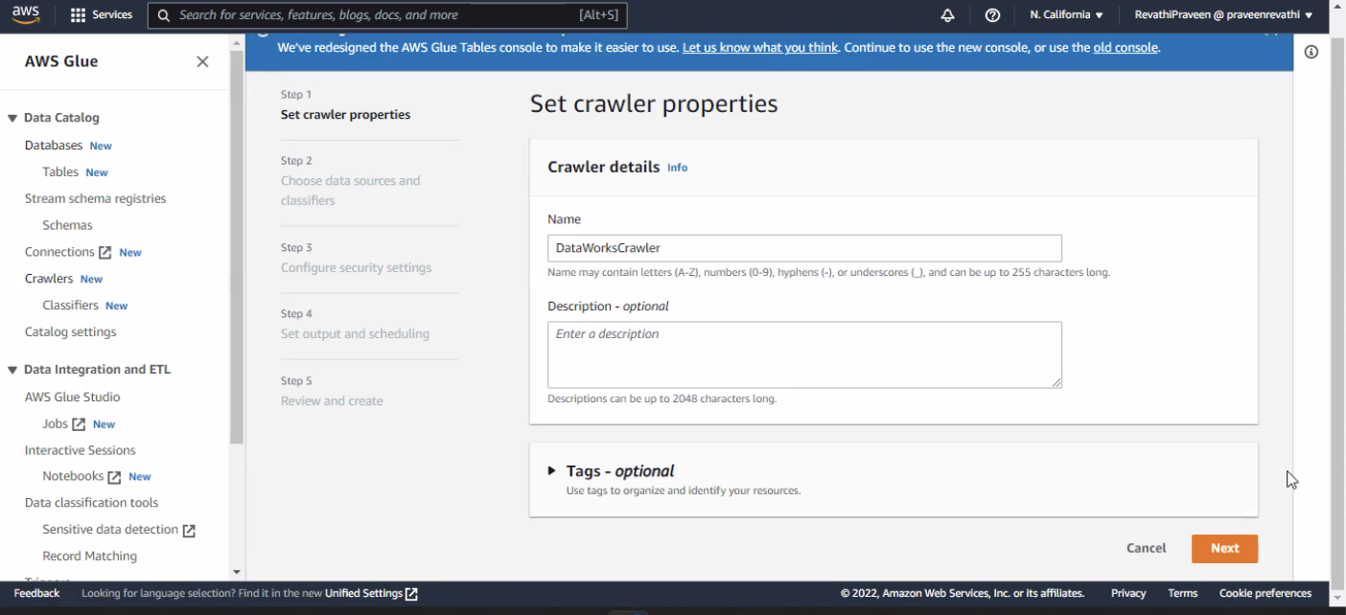

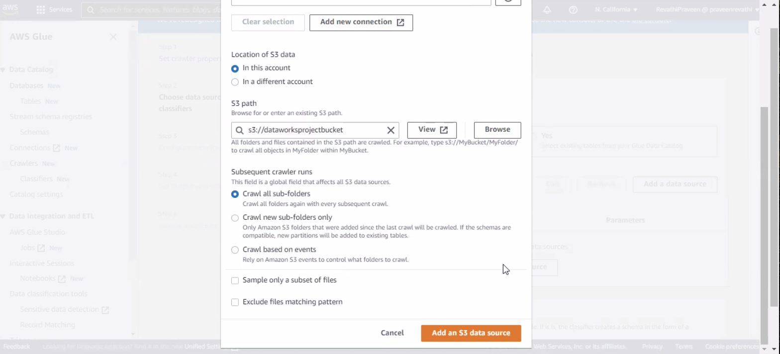

1. Setting IAM role

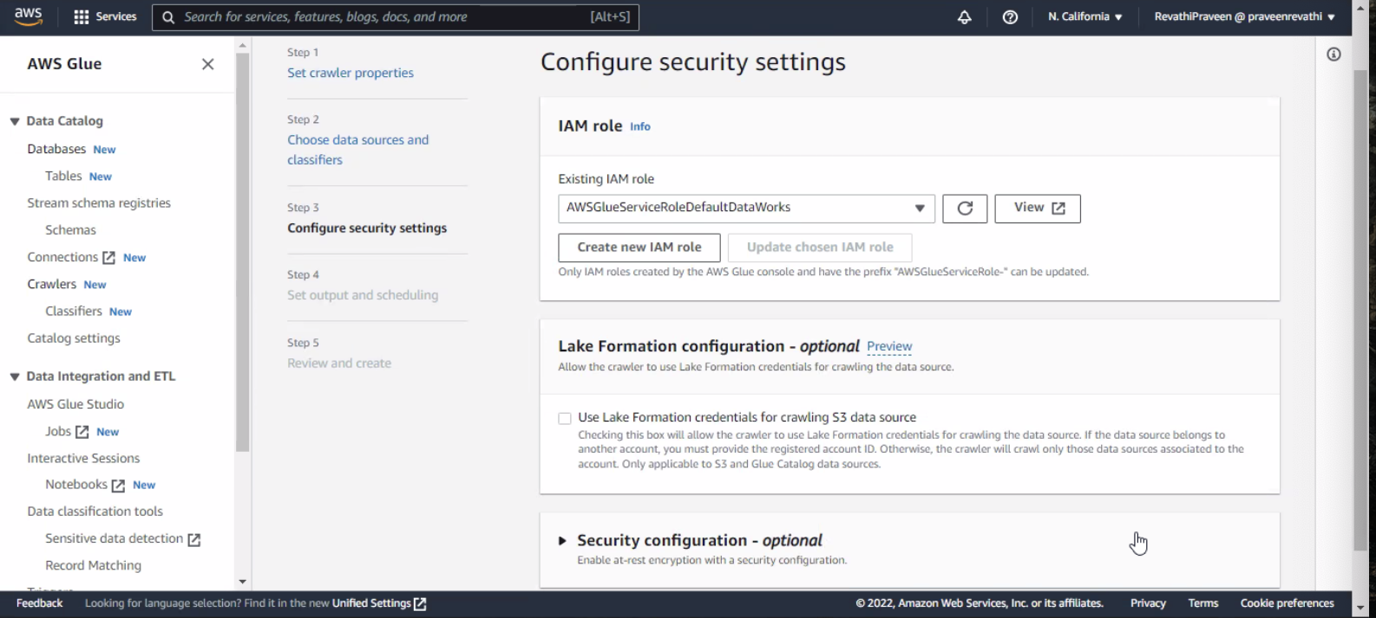

1. Creating database “dataworksgluedb”

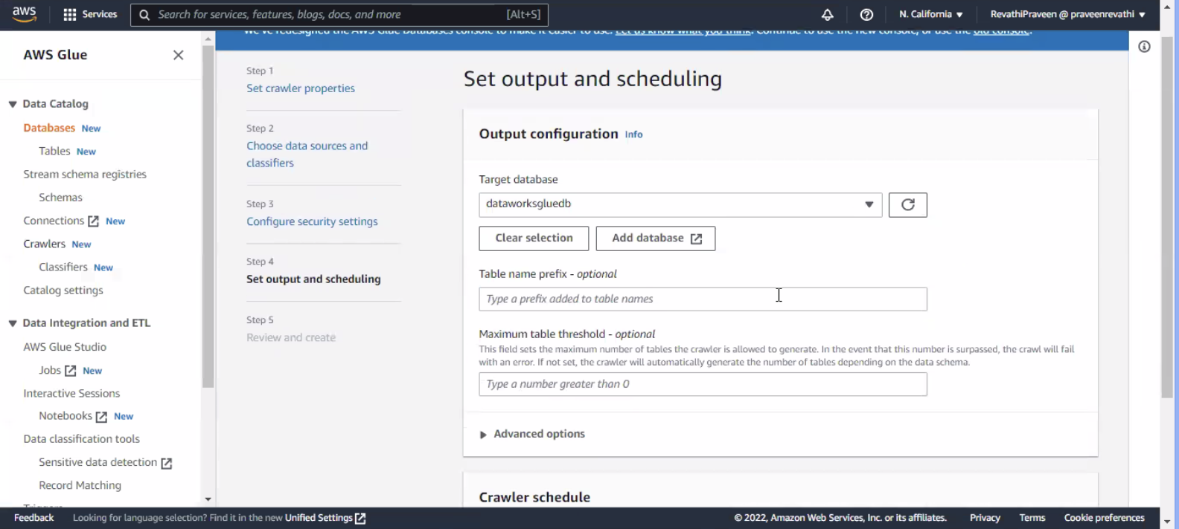

D. Create table “ DataWorksTableAWS”

This would ensure that the data in the table is queried by the ETL job of Glue

E. Create job and set up the IAM role

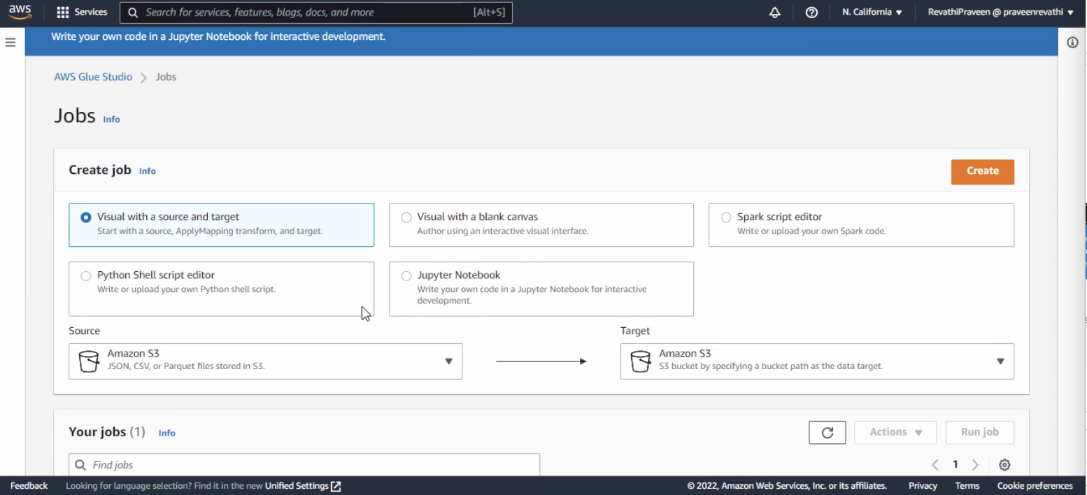

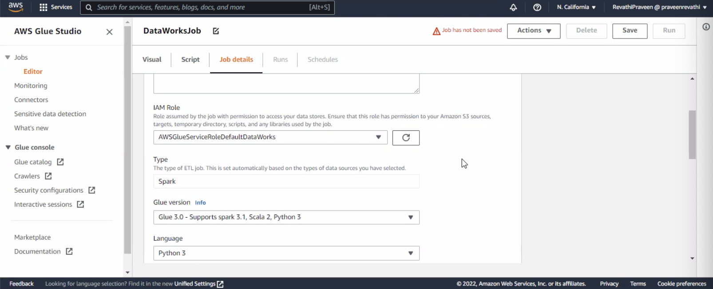

F. We can see from the figure , the data from S3 bucket is loaded into Glue and the ETL process is successful.

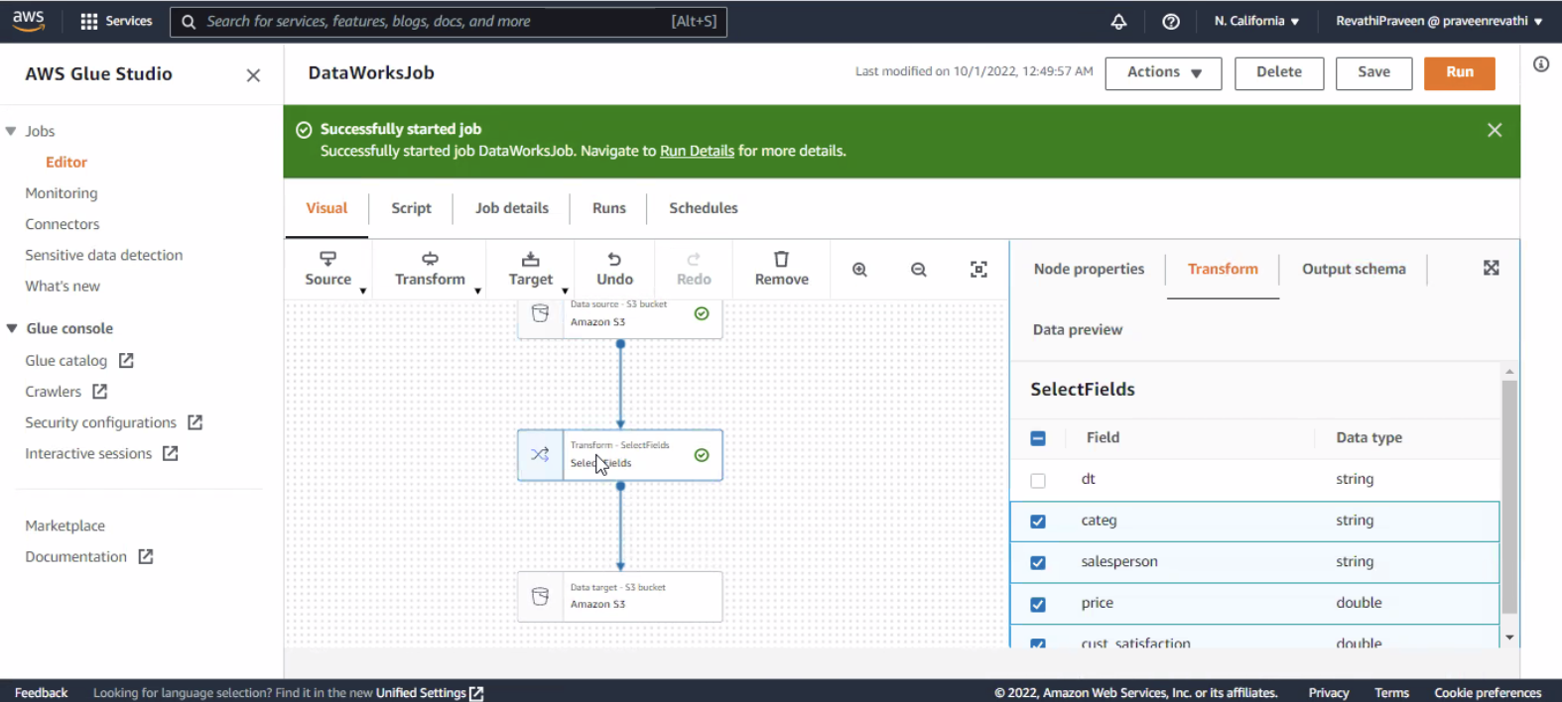

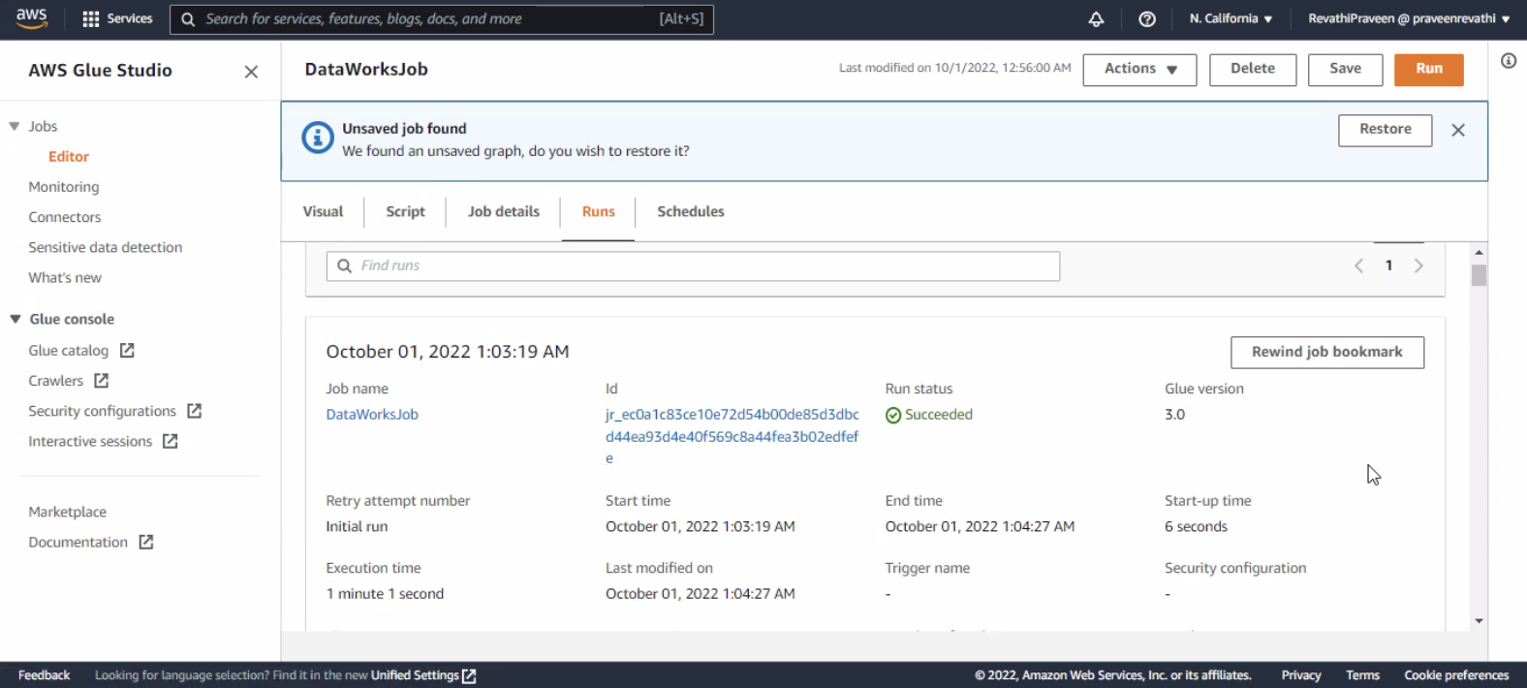

G. We can see the data is loaded from source S3 bucket and copied to target S3 location.

